Grade:IV Subtraction

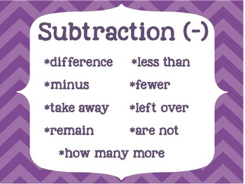
Word problems based on subtraction are of several types:
1. The girls had 3 weeks to sell tickets for their play. In the first week, they sold 75 tickets. In the second week they sold 108 tickets and in the third week they sold 210 tickets. How may tickets did they sell in all?
Tickets sold in the first week = 75
Tickets sold in the second week = 108
Tickets sold in the third week = 210
Total number of tickets sold = 75 + 108 + 210 = 393
Answer: 393 tickets were sold in all.
2. Mr. Bose spent $450 for petrol on Wednesday. He spent $125 more than that on Thursday. How much did he spend on petrol on those two days.
This problem has to be solved in two steps.
Step 1: Money spent for petrol on Thursday
450 + 125 = $575
Step 2: Money spent for petrol on both days
450 + 575 = $1025

